InternPro Report

Portfolio builder for freelancer Project Report

**Team Members**

This project was collaboratively developed during the Interpro internship by the following team members:

1. Kishan M Naidu
2. Pawan kumar rai
3. JhansiLaxmi Bhatlapenumarthi
4. S. Pardhu Krishna
5. Eppa Nandini
6. Janani S
7. Sanket Thakre
8. Sanidhya Suman Thakur
9. Atchaya A
10. Roith Pal
11. Ganesh puvvala

**Task :  
Develop the “Portfolio builder for freelancer” web application focused on enabling freelancers and creatives to build online portfolios. The project was developed as part of a 6-week internship at Interpro.**

**Work Done:  
• Implemented secure user authentication (signup, login, logout) using PHP and MySQL.  
• Designed and integrated three customizable, responsive portfolio templates.  
• Integrated frontend customization using Alpine.js for dynamic editing (template3).  
• Added scroll animations and PDF export features using AOS and html2pdf.js.  
• Developed project, skill, and certification management functionalities.  
• Configured database and local server environment for testing and development.**

Project Details

**Project Title: Portfolio builder for freelancer**

***Features Implemented:*  
• Secure User Authentication System  
• Multiple Responsive Templates: Minimal, Creative, Professional  
• Frontend Customization with Alpine.js (template3)  
• AOS animations & PDF export (template2)  
• Dashboard integration and user session handling  
• Contact form section for direct inquiries**

***Technologies Used:*  
• PHP (Backend)  
• MySQL (Database)  
• HTML5, CSS3, Tailwind CSS  
• JavaScript, Alpine.js, AOS, html2pdf.js  
• Font Awesome**

***Guidelines Followed:*  
• Responsive design with clean UI  
• Organized file structure and semantic HTML  
• Consistent styling with Tailwind CSS  
• Proper database normalization and security  
• GitHub version control for collaborative development**

***GitHub Repository:***[**https://github.com/Kishan2123/Portflolio-builder**](https://github.com/Kishan2123/Portflolio-builder)

<https://github.com/Pawan210804/project-Portfolio-Builder-forFreelancer.git>

Project Approach

***Approach to the Task:*  
Started with planning the core modules and gradually developed backend and frontend. Focused on delivering functionality in small iterations and integrated styling and JS features after basic layout.**

***Steps Taken:*  
• Defined user stories and requirements.  
• Designed UI wireframes for each template.  
• Coded authentication system in PHP.  
• Connected MySQL database for user data.  
• Integrated and styled portfolio templates.  
• Deployed project on local server and debugged issues.**

***Details of web page / list of figures:***

*Landing page/login:*

Login setup:

User are required to fill the details to access the dashboard

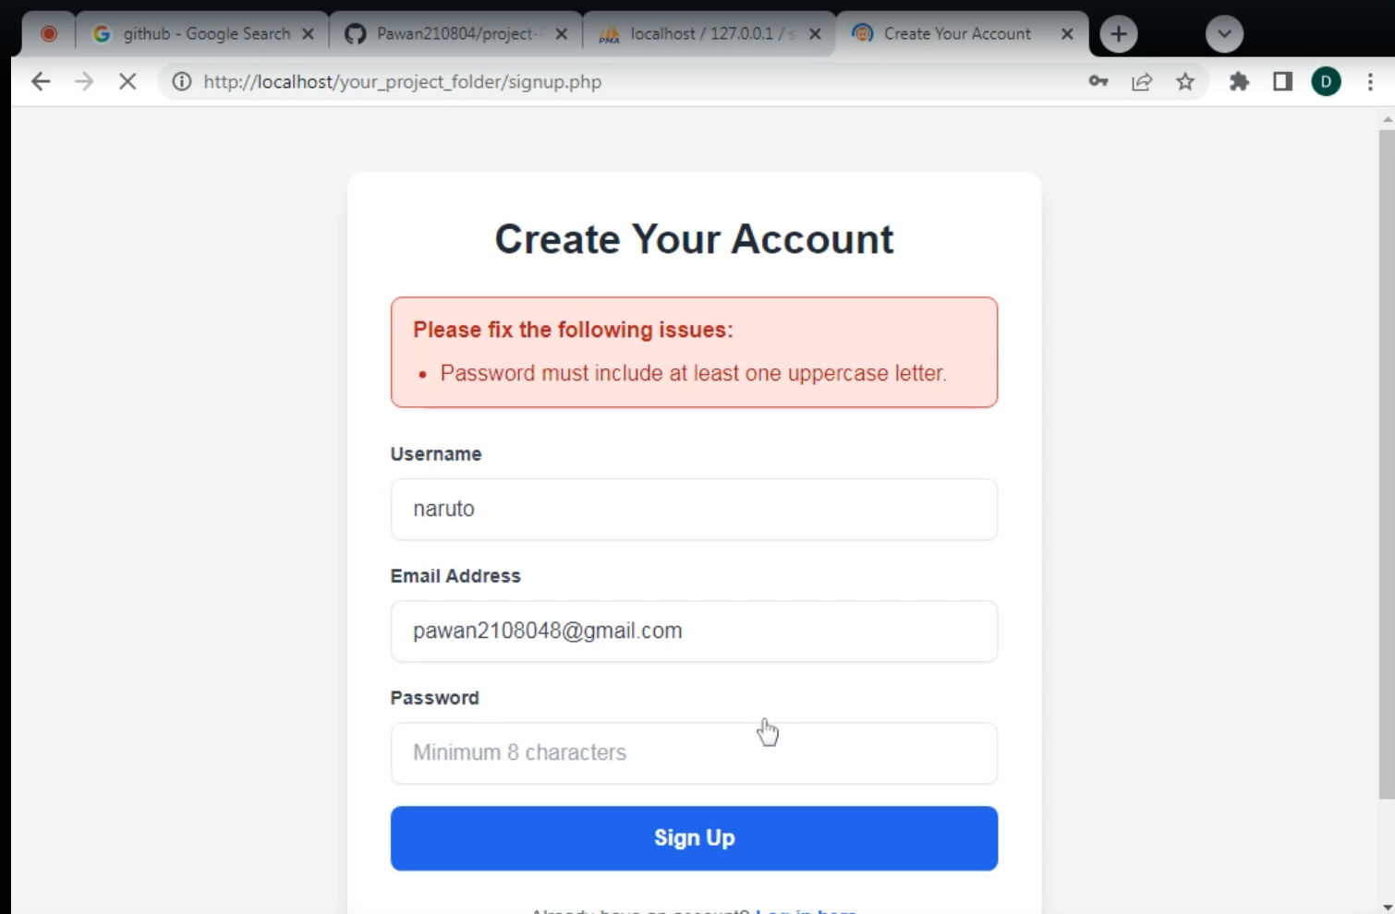

*DashBoard/user panel:*

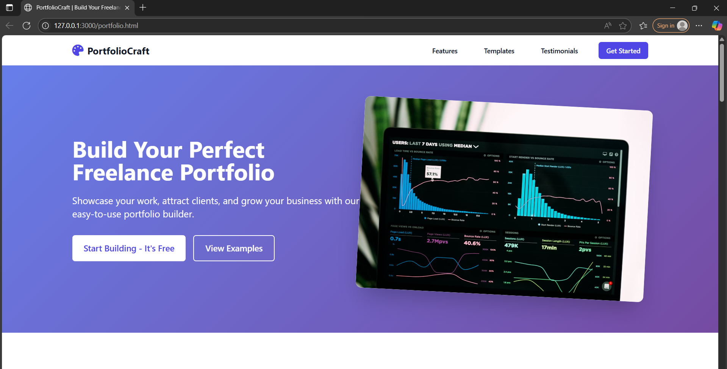

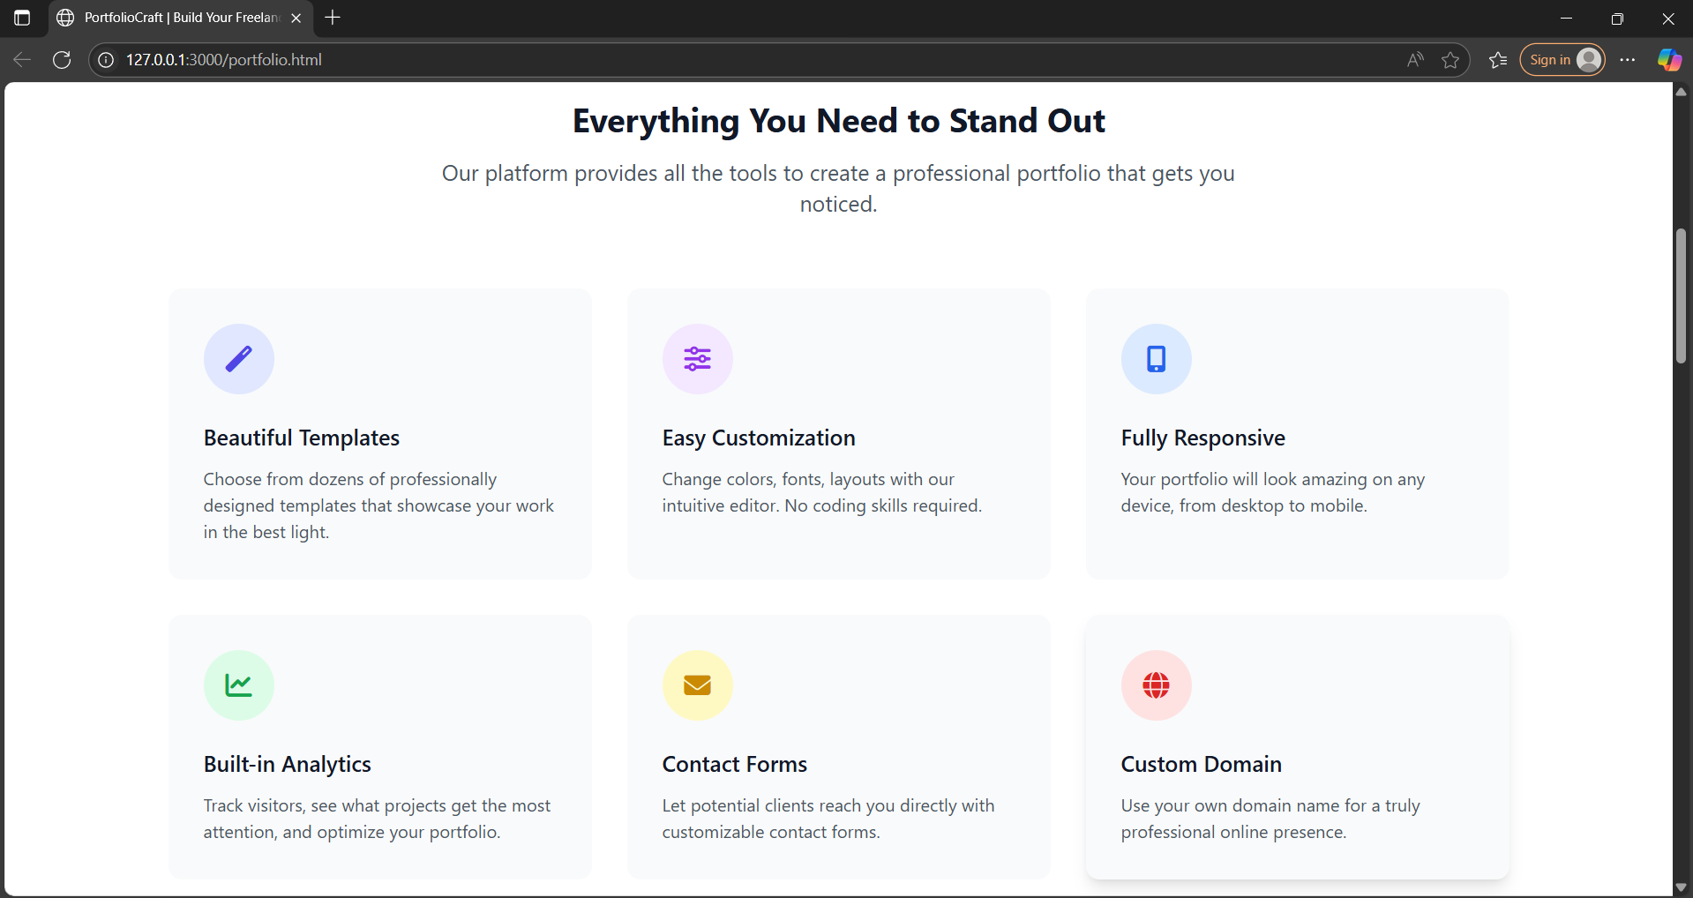 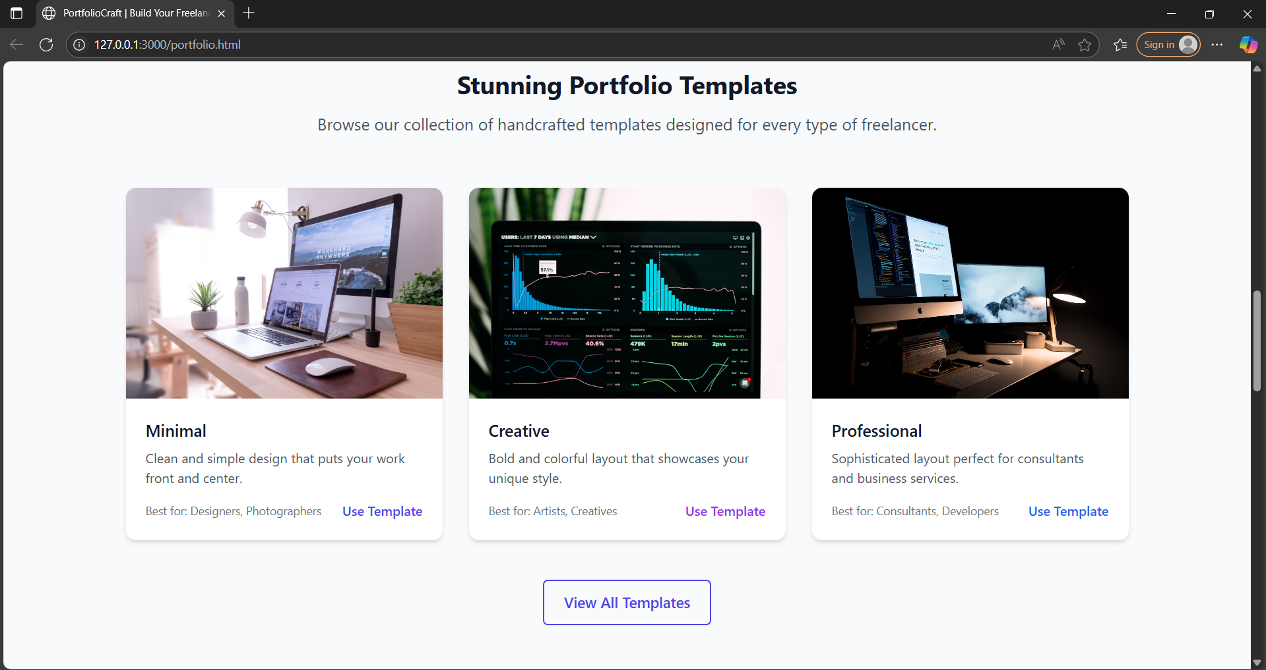

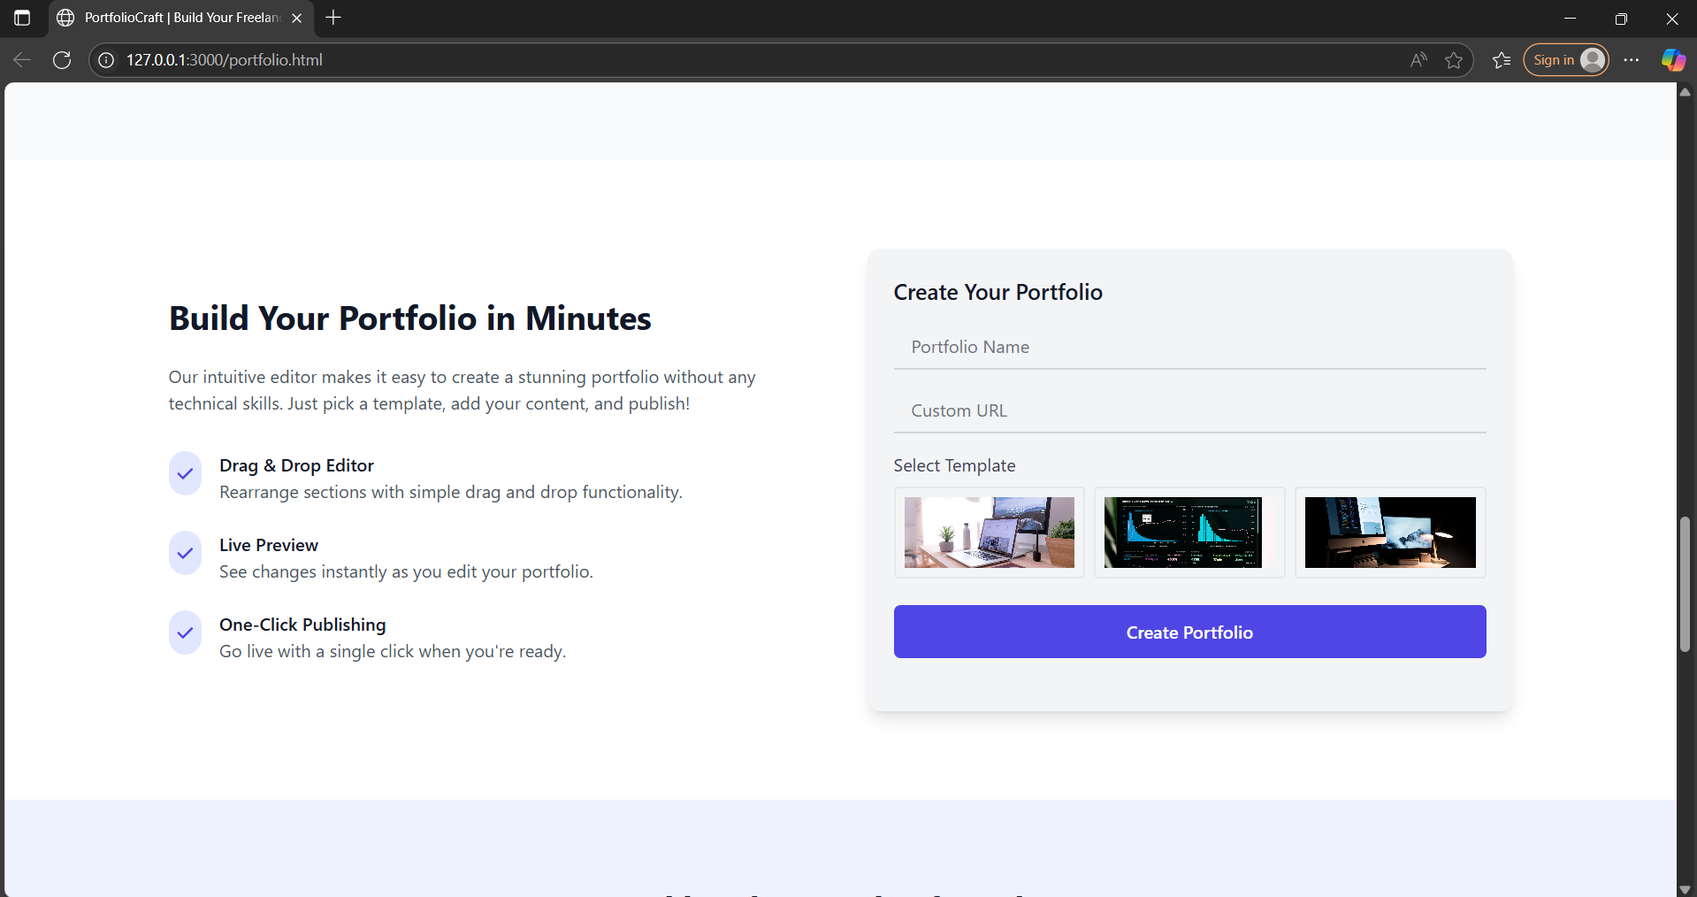

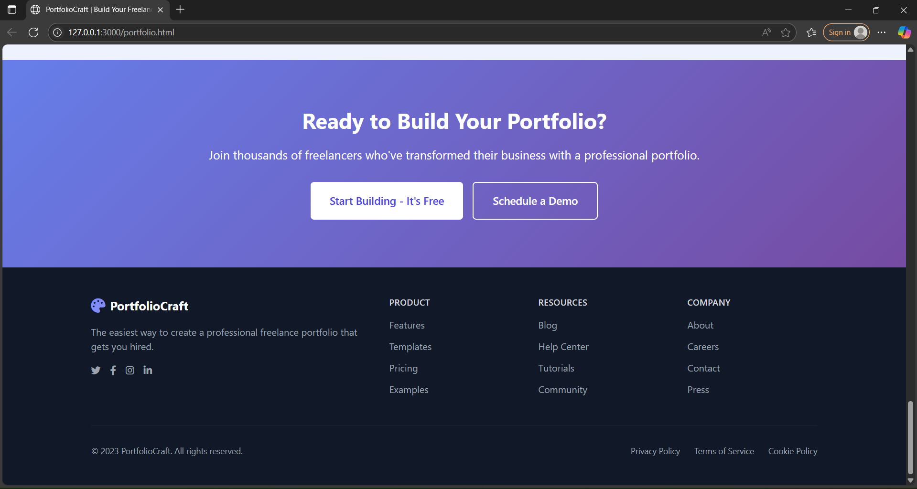

**Dashboard is well designed and every essential element is navigated for the user and an easy way to access and utilise it .**

**Promoting templates to trusted members of this application with a detailed need to stand out.**

*Templates:*

TEMPLATE 01:- 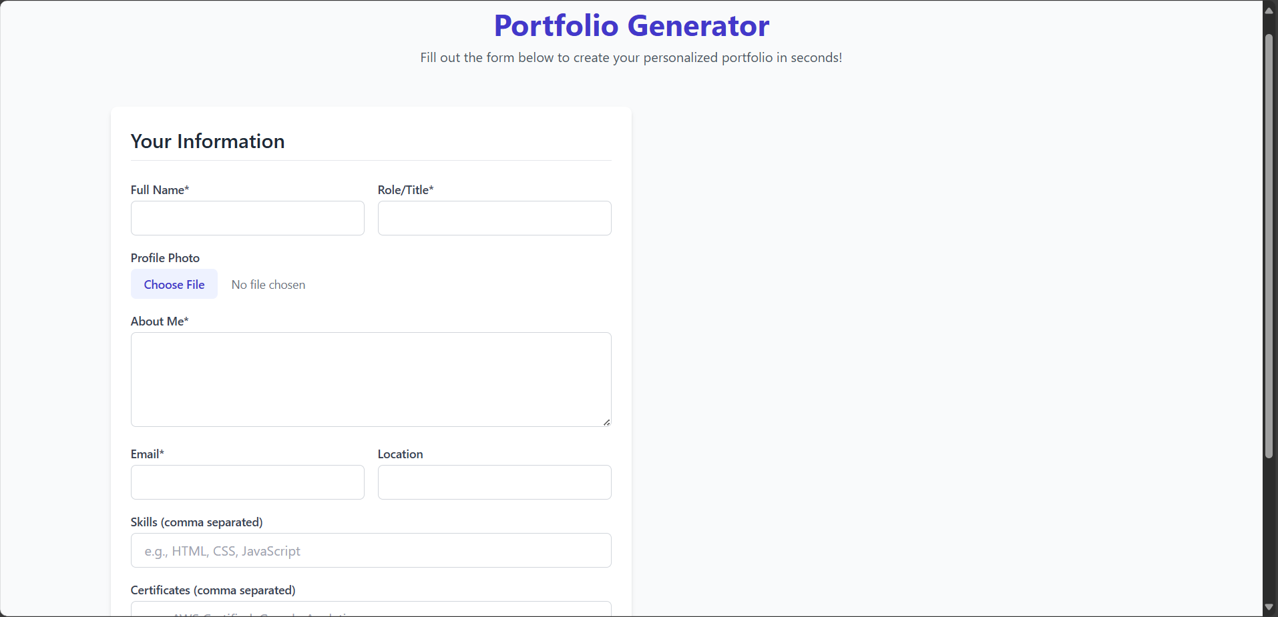

A Basically design for those freelancers who are beginners. Including a minimal set of details about their work and themselves. And allowing the user to download the webpage after filling the template.

TEMPLATE 02:-

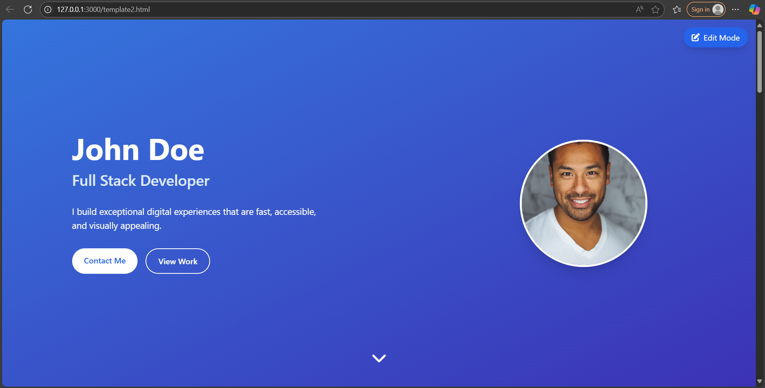

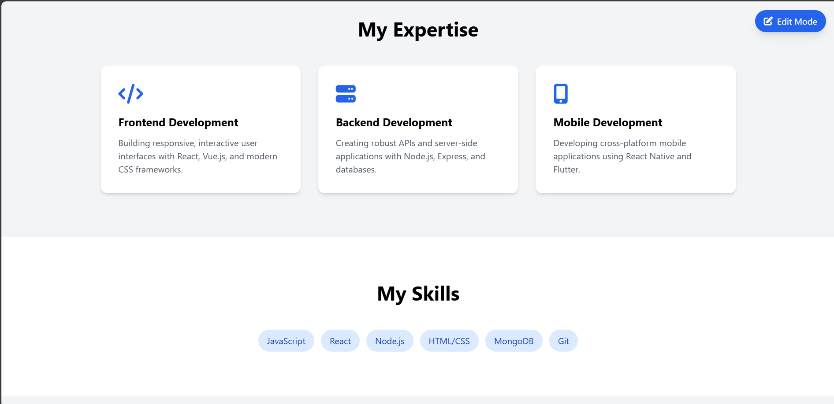

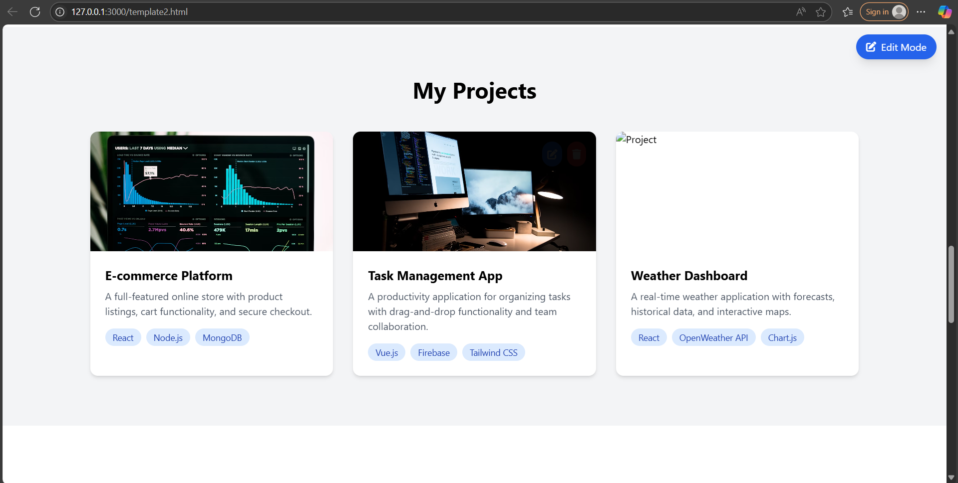

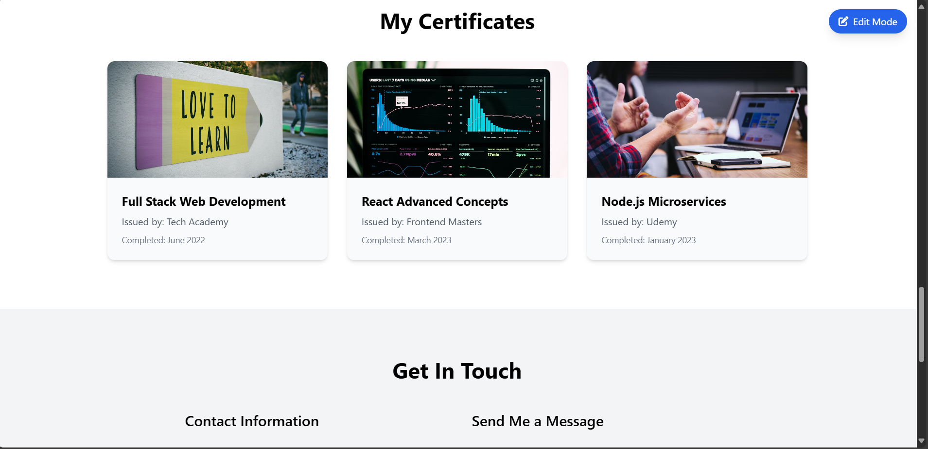



An animated and editable version of template including all their work certificates and many more which enhances the customer to seek towards freelancers. Including a part where to connect them after they look over their portfolio page.

TEMPLATE 03:-

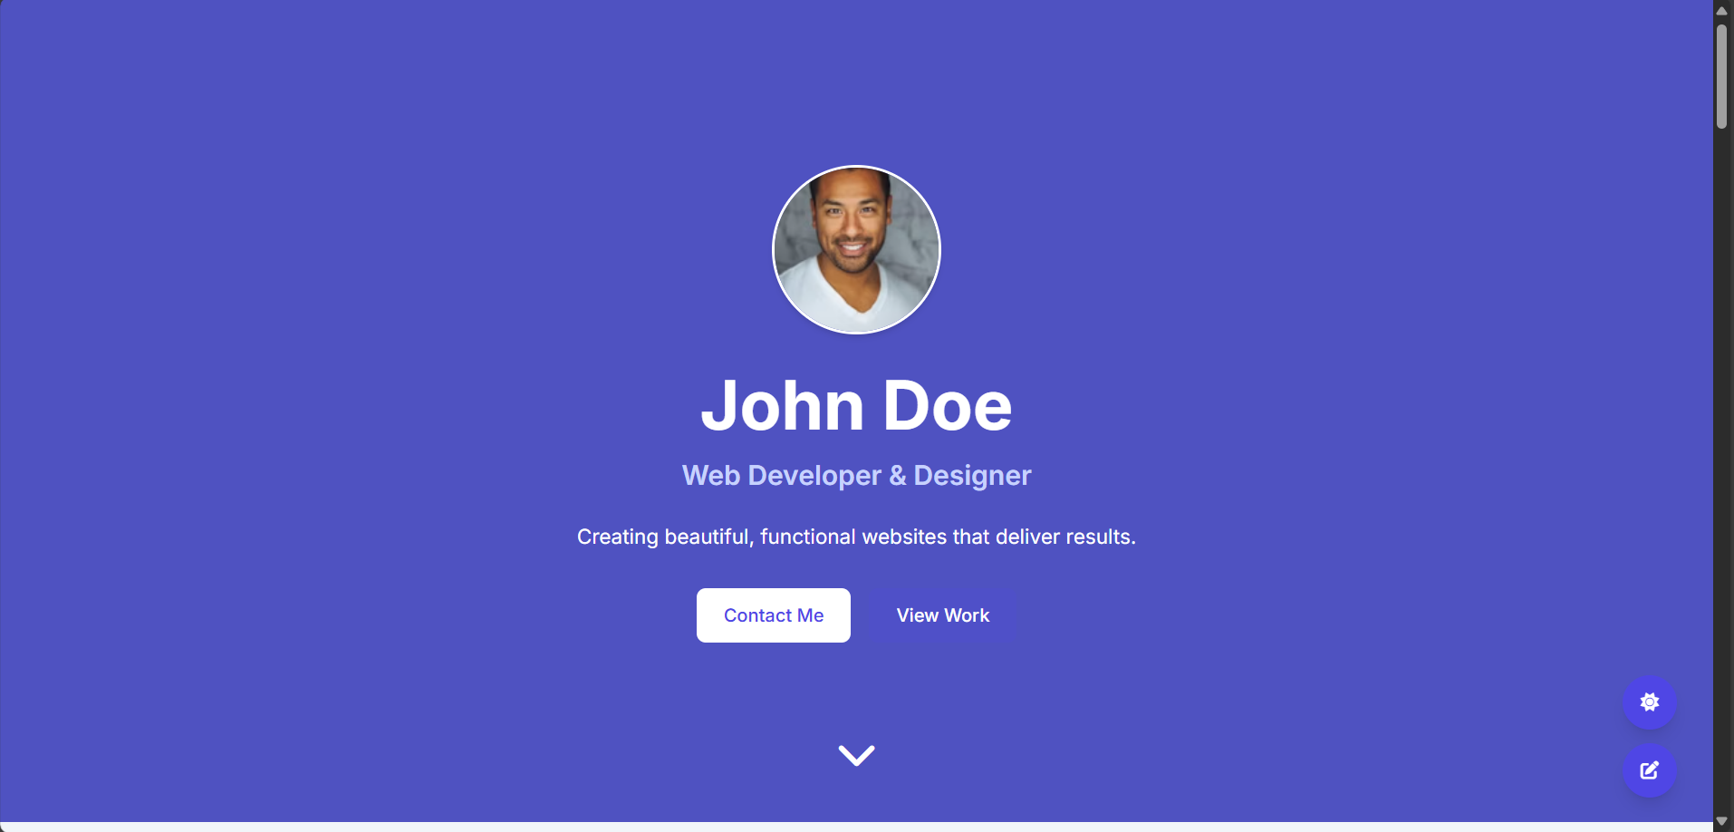

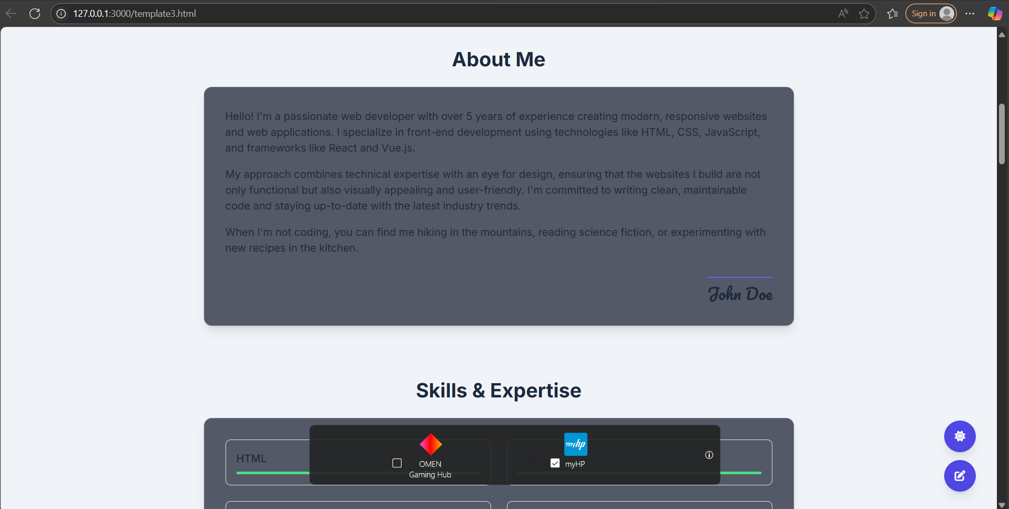

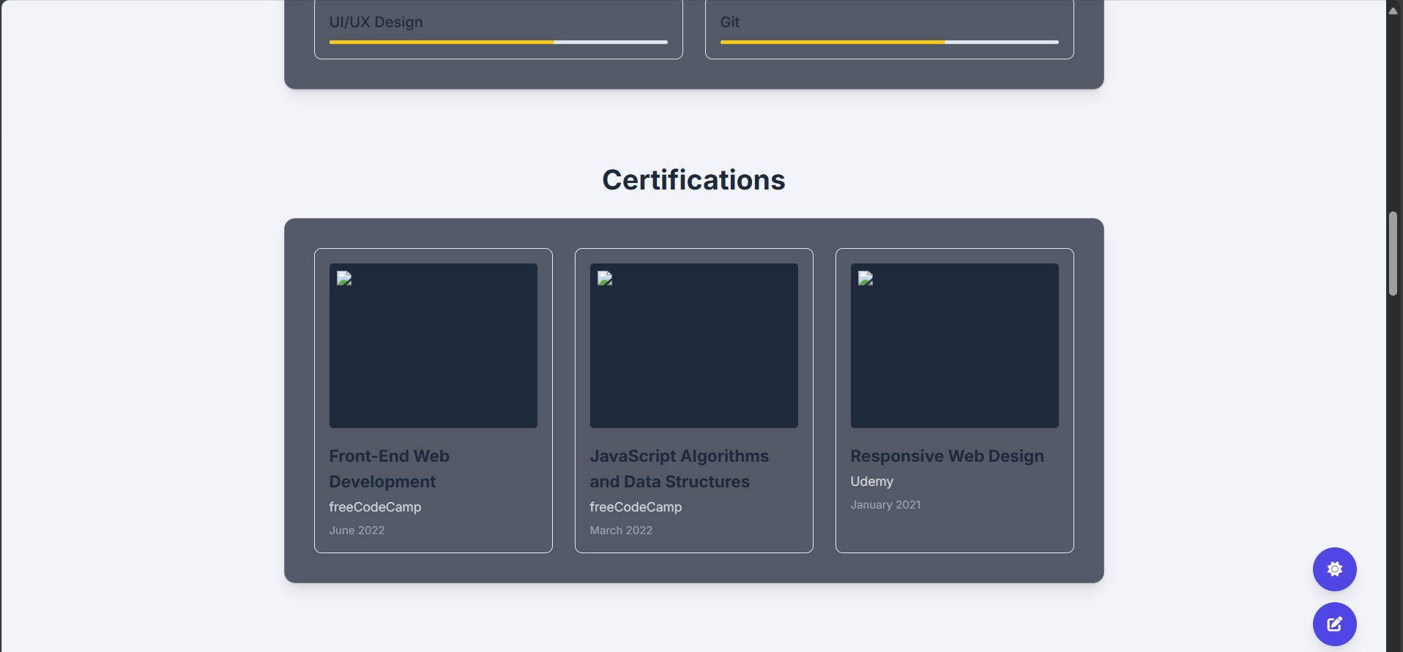 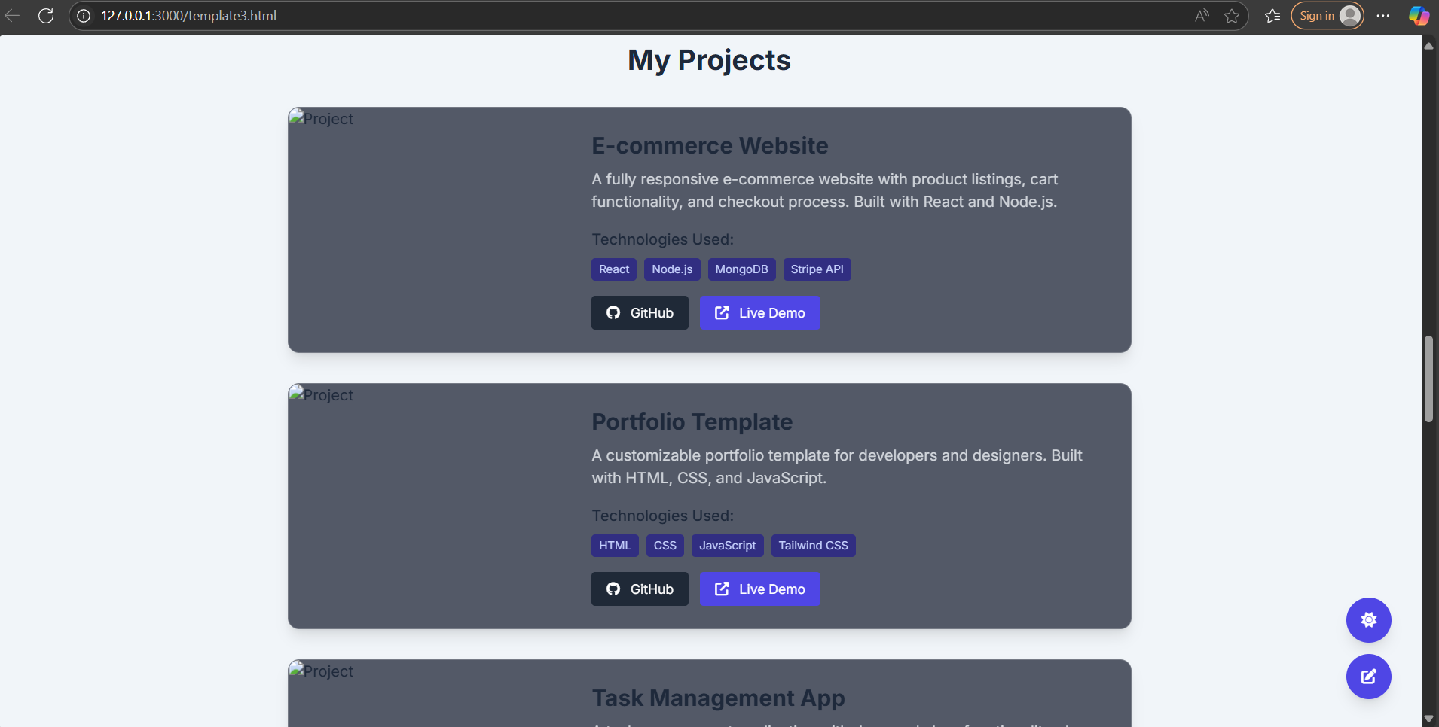

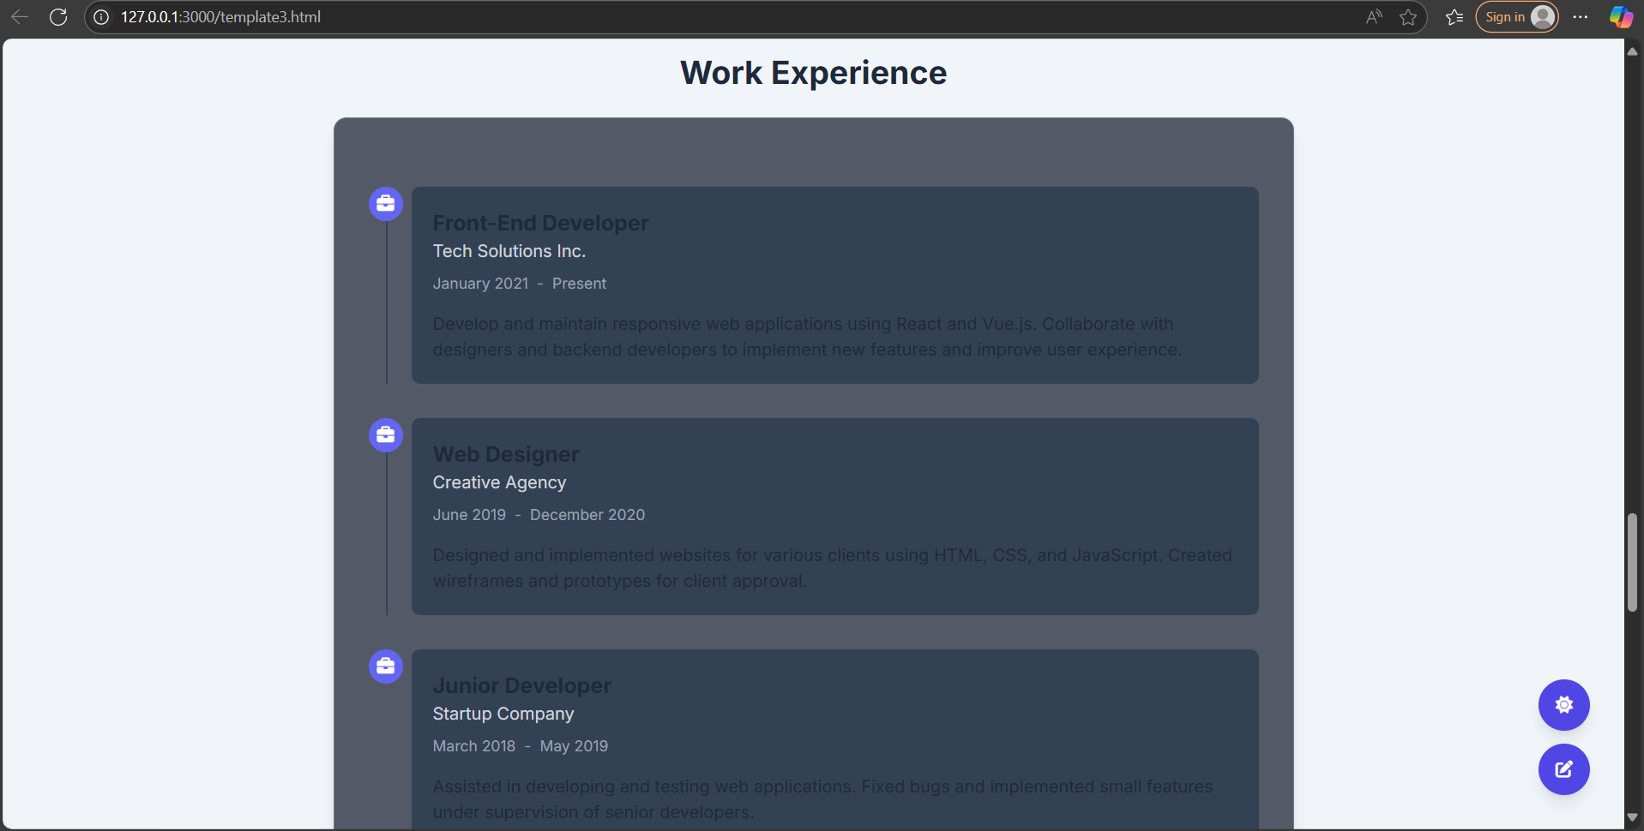

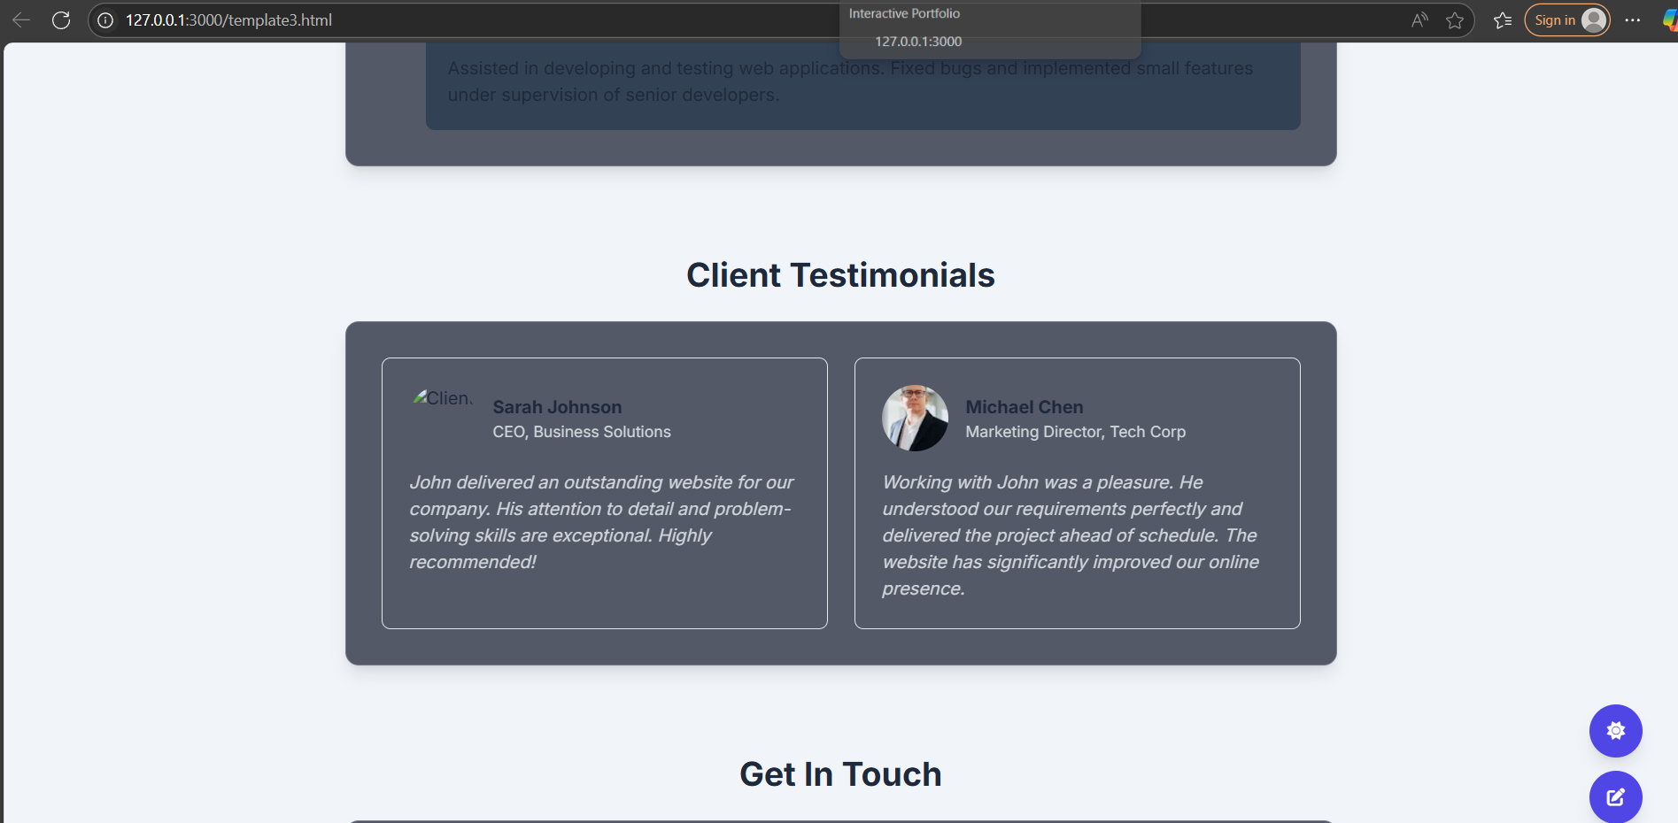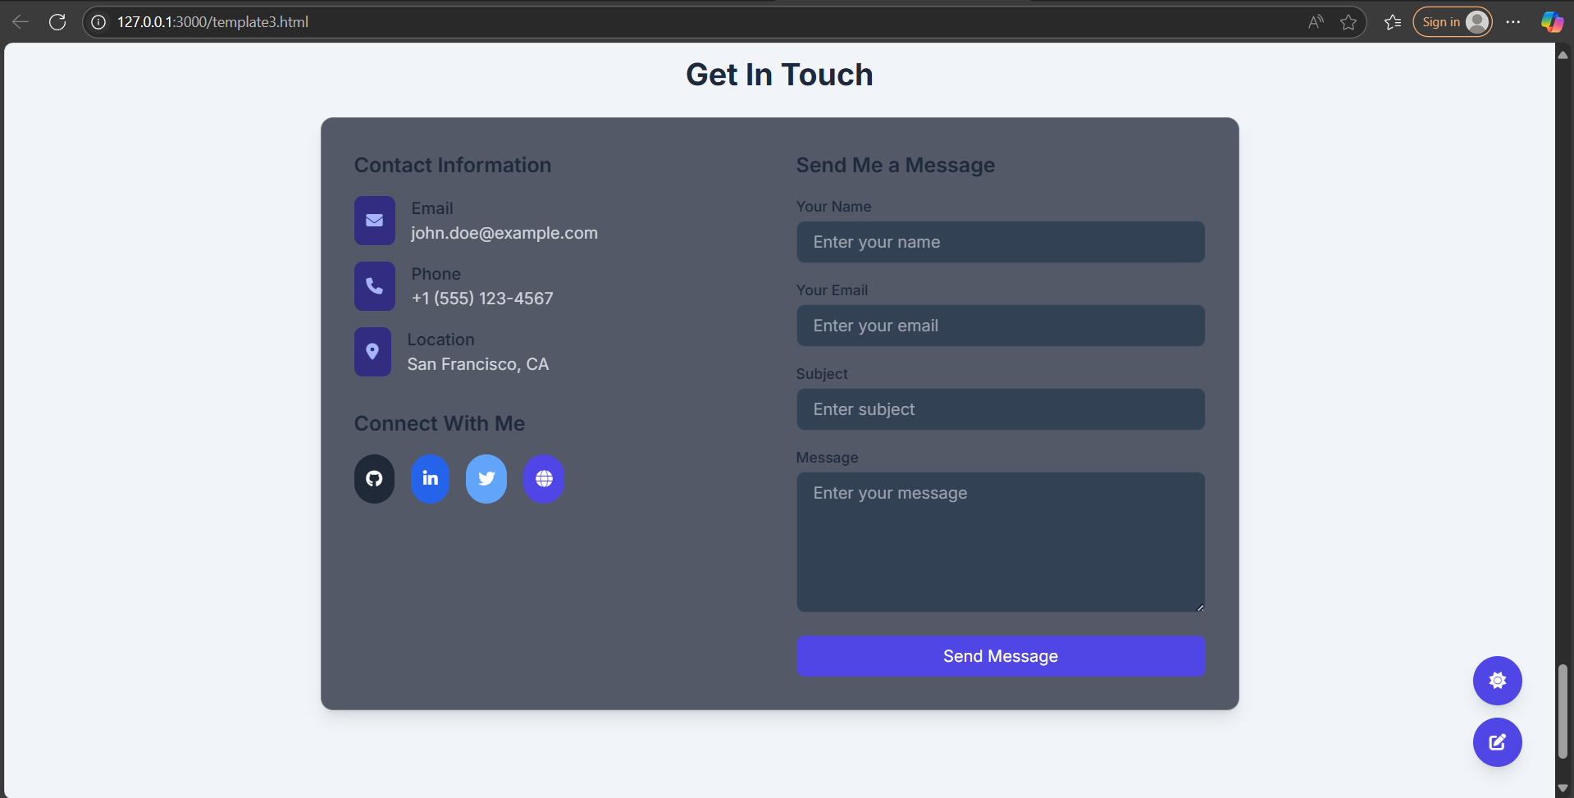

Template 3 includes all features with additional features which makes freelancer uniqueness . It has a feedback session from the clients . Which will enhance more in engaging the services and customer centric approach.

***Learning Outcome:*  
• Full-stack web development using PHP and MySQL  
• Client-side interactivity with Alpine.js and Tailwind CSS  
• Scroll animations and PDF generation in browser  
• Handling form data and session-based access  
• Version control and collaborative development on GitHub**

**Conclusion:  
The Portfolio builder for freelancer project allowed me to practice backend and frontend integration while designing a user-friendly tool for freelancers. I now understand how to structure scalable web apps and use dynamic content rendering. Future enhancements could include user dashboards, analytics, and export to resume builders.**